Honors thesis

MASTER COURSE OF ARCHITECTURE CONSTRUCTION CITY

Abstract

Renovation of Hanglai Village

Tutor | by
Michele Bonino  Li Xiaodong | Germana Isacco  Chiara menna

February 2018

Hanglai is the village in the Hunan Province of South China which we investigate
in our thesis, because of its exemplary preservation of the authenticity of the site and the
presence of the peculiar minority Miao. Those two are indispensable elements to reach our
intent to discover the other China, far from the western Haidan district, where Tsinghua campus is located. Our research starts with a look at the Chinese reality to understand the central government's attitude towards the extreme poverty of the countryside, which is in sharp contrast to the dense urbanization of the New Town. The two phenomena, albeit with regard to totally opposite realities are linked. The abandonment of villages involves massive urbanization. Both have a single problem: the loss of China's authenticity and the
enlargement of the gap between cities and countryside. The central government, however,
is recently implementing policies to redirect these two trends: (1) the New Urbanization
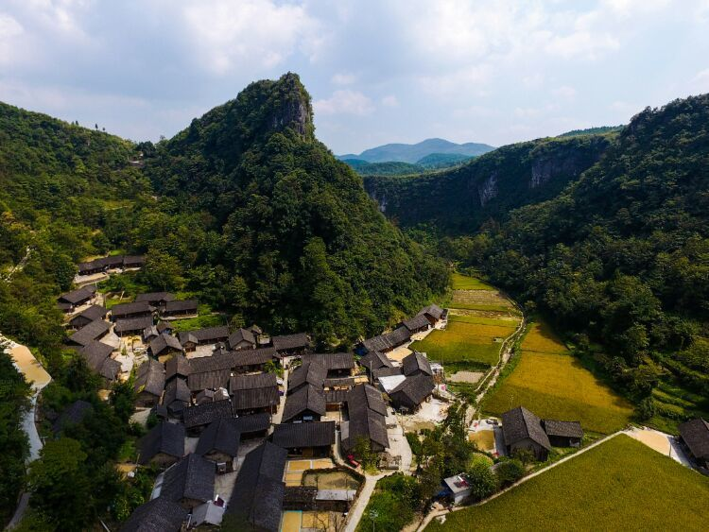
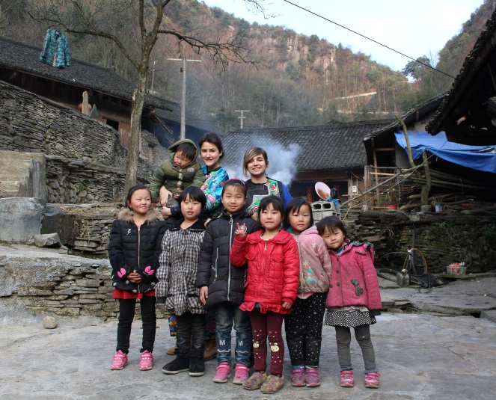
Plan 2014-2020, aimed at a conscious and sustainable urban expansion, and the amelioration of the city-country gap with targeted population action. (2 ) A plan on the recovery of rural villages through different actions, such as museum solutions, wellness tourism, social housing and population services in general. Analyzing to the complexity of the phenomenon, we realized since the beginning that it was necessary to go to the place, despite the suggestions of choosing a more convenient site, to understand this particular reality, and thus formally our point of view in this regard. We met locals and lived with them to understand their main needs. So we realized that our design approach had to set aside the creator's ego and focus on the analysis of the local context and culture to maximize local resources as well as the constructive habits of the inhabitants. Our project wants to be an alternative to local policies that despite our own goal do not always solve it. It is not building a home that improves a village, but through a strategy that takes into account different aspects and aims at improving the local economy and preserving tradition and authenticity. So our project does not only provide for the restoration of dwellings or a simple sky dumped building in a site, but a global approach.

For further information please contact:
Germana Isacco, germana.isacco@gmail.com
Chiara Menna, mennarosa1984@gmail.com

